Installments (QSOPS)

User Manual

Version 0.0.0

Feb 23, 2021

QuickFee Limied

|  |  |  |
| --- | --- | --- |
| Approved | Checked | Created |
|  |  |  |

**Contents**

1 Preface 1

1.1 Purpose of the Document 1

1.2 Audience 1

1.3 Definitions, Acronyms and Abbreviations 1

1.4 Introduction 1

2 Features Description 1

2.1 Landing Page 1

2.2 Payment Process 2

2.2.1 First Step. Invoice Information 2

2.2.2 Second step. Payment Details 3

2.2.3 Final Step 4

# Preface

## Purpose of the Document

The purpose of this document is to provide detailed instructions on how to use the QSOPS web-application of version 0.0.0.

## Audience

This User Manual is targeted to:

* Users who will pay for a service using the QSOP web-application.

## Definitions, Acronyms and Abbreviations

|  |  |
| --- | --- |
| **Term** | **Description** |
| Spliitit | payment method enabling customers to pay for online purchases by splitting the cost into interest-free monthly payments on an existing credit or debit card. |
| Pre-authorized amount | the entire amount of the payment. |
| Installment | payment amount a user has to pay monthly. |
| Interest | the amount a lender charges for the use of assets. |

*Table 1. Definitions, Acronyms and Abbreviations*

## Introduction

Application Overview

QSOP application is a service for processing payments from customers to their service providers. The application allows customer to make payments by splitting them into equal 4 monthly payments without charging any interest fee. Customers can pay using credit or debit card.

|  |
| --- |
| **Note:**  For more system functionality description, please see below. |

# Features Description

## Landing Page

Landing page is a page, where the payment process starts. To get to this page, you should get a link from a service provider or to click a corresponding link on their web-site (to initiate payment process).

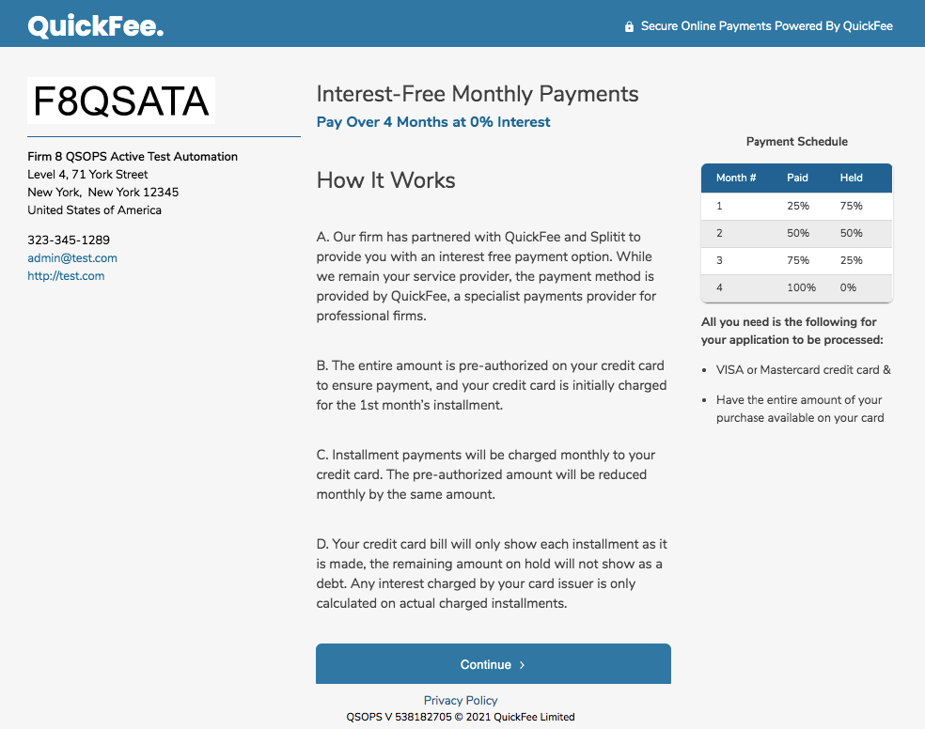

*Figure 1. Landing Page*

On the left side of the screen you will see the information about the firm you are going to pay to. In the middle and on the right – there is the explanation of how the payments will be charged to your credit card and conditions.

## Payment Process

To start payment, click “Continue” button on the Landing Page.

### First Step. Invoice Information

Enter the number of your invoice/matter or other document and payment amount. If you follow the link generated by your service provider, Invoice number and payment amount will be pre-populated.

On the right side in the “Payment Schedule” table you will see your monthly payment amount the payment schedule. In the middle in the “Payment Summary” table you can find the total amount of the payment, including the Surcharge amount for payment processing.

You can go back to the previous page, if you want to read terms and conditions one more time or you can proceed with your payment by clicking “Continue” button.

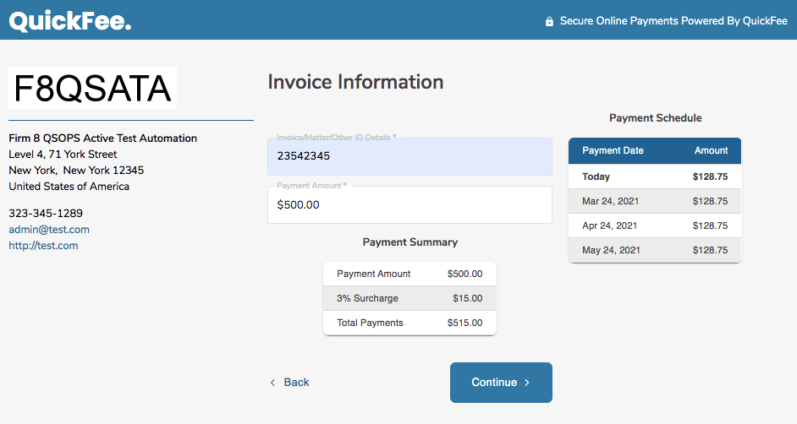

*Figure 2. First Step. Invoice Information.*

### Second step. Payment Details

On this page you need to provide payment details to finish the payment.

Choose, whether you are a firm representative (Business) or an Individual. Then provide your personal information, contact details, address. In the grey box input your card number details. QuickFee doesn’t get your bank information, it goes directly to the payment provider. Make sure you are using a Visa® or Mastercard® credit card and that your credit card has enough available credit to cover the Total Payments amount. Read terms and conditions page, and if you agree, tick the corresponding checkbox and then – “Pay Now” button.

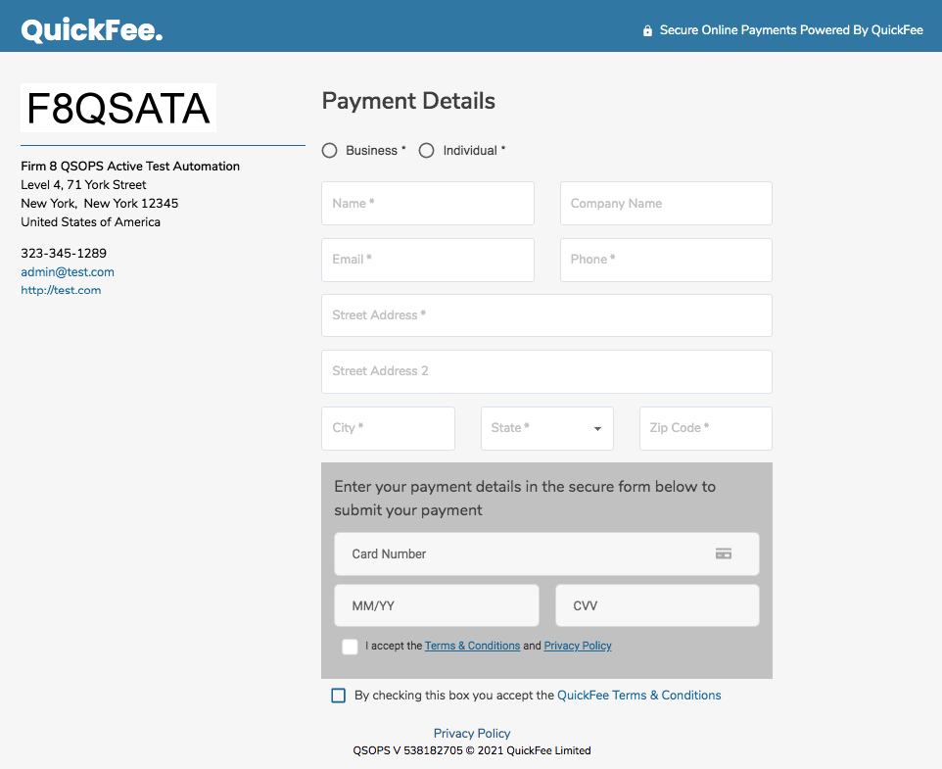

*Figure 3. Second Step. Payment Details.*

### Final Step

After the payment has been successfully submitted, you will see the “Thank You” page informing you about the amount that was charged pre-authorized on your credit card, payment reference number. If any problem appears on the Splitit or bank side, you will be informed about it immediately.

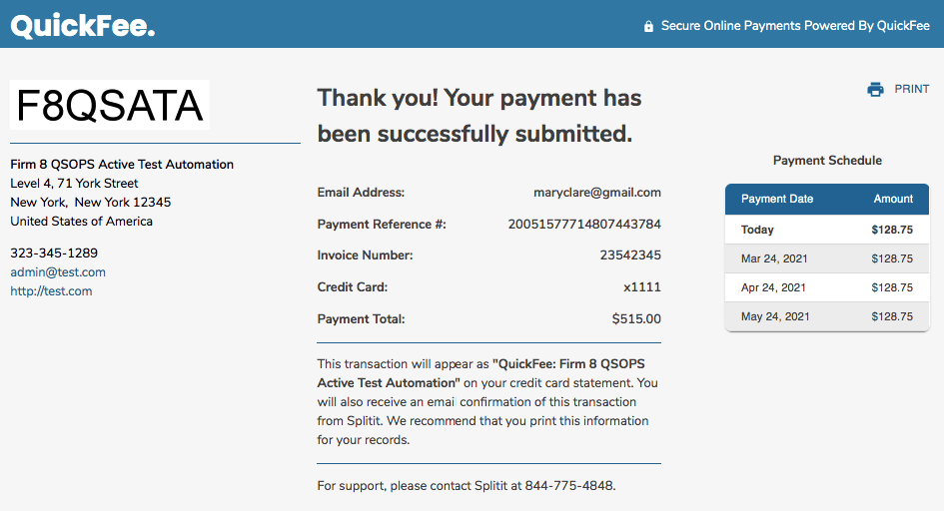

*Figure 4. Final Step.*